**Day 2 Lab Assignments**

**Do the following Assignments (Try to make your pages HTML5 valid, and don’t use deprecated tags or attributes):**

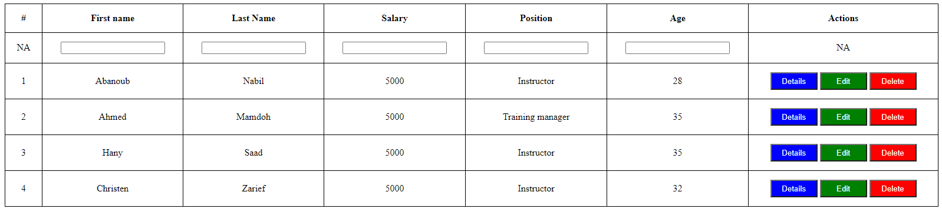 1-Design the following table

2-Create Registration from with the following fields (Don’t use tables with the form):

* 1. User ID (Hidden)
  2. First name (Required)
  3. Last Name (Required)
  4. Email (Required, Email)
  5. Password (password)
  6. Birth Date (Date picker)
  7. User Picture (file)
  8. Gender [Male of Female] (Radio button, in feildset)
  9. Faculty (Dropdown list)
  10. Interests [Programming, reading, swimming,..](Checkbox in fieldset)
  11. About you (Text area)
  12. I agreed to terms and condition checkbox (make it link to terms and condition page that opens in new tab)
  13. Submit and reset buttons

**Use the following:**

1. Labels instead of plain text for form elements
2. Adjust tab index and use access key.
3. HTML 5 new inputs and validation attributes.
4. Submit button redirect user to page named (Thankyou.htm), which contains text:

**Thank you for your registration.**

1. Use get method.
   1. 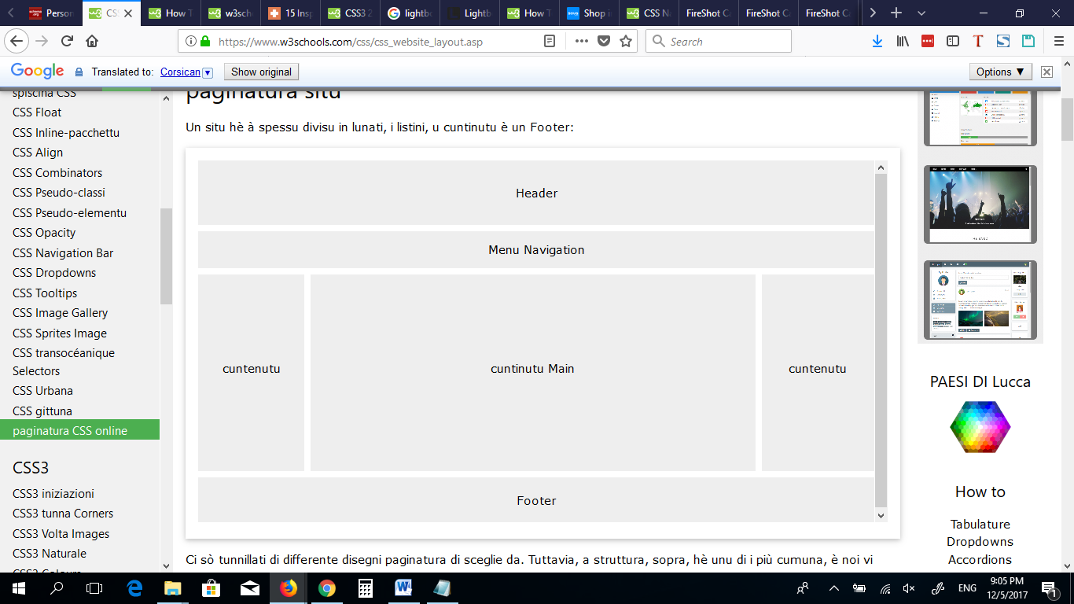What’s the difference between get and post methods?

Design the following template (we want only how to use new tags)

**<Thank> YOU </Thank>**